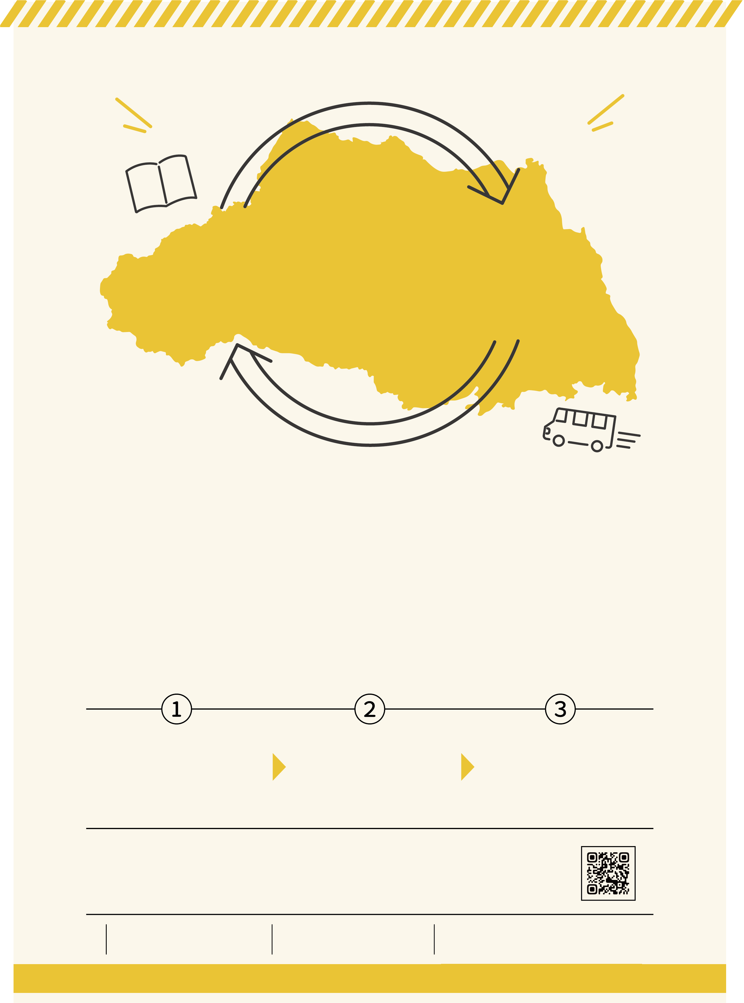

**25 million books for you**

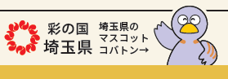

**Books held by prefectural libraries are available at your local library.**

Libraries in Saitama Prefecture, such as prefectural and municipal libraries as well as some universities and institutes, have formed a mutual cooperation network to provide each other with the books their users are looking for.

The whole of Saitama Prefecture is like one large library.

Interlibrary loan service enables you to borrow books that are not held by your local library from other libraries in the prefecture.

Please feel free to use this service.

Here is our website to access on your smart phone.

・You can also explore the web to locate books that are not in the catalog of your local library.

Search results are displayed in Japanese only.

・Each library has different borrowing conditions, such as "New books cannot be ordered for a certain period

of time."For details, please contact your local library.

・Please allow extra time for requesting items through the interlibrary loan service.

Thank you for your understanding.

We are here to support your research!

**You can request books not available at your local library, for free.**

Kuki library

TEL 0480-21-2659

Your requested books will be delivered to your local library for pick up, where you can both check out the books and later return them.

The requested books will be transported from the supplying library to your local library in a prefectural library vehicle.

Kumagaya Library

TEL 048-523-6291

You can make a book request at your local library. Please ask at each library about application procedures.

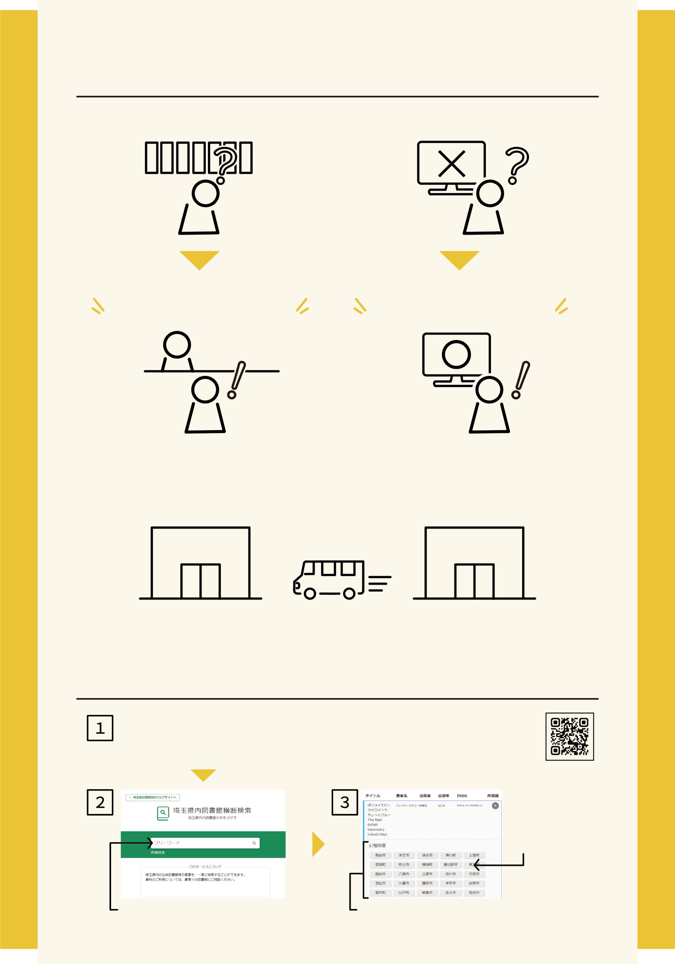

Here is our website to access on your smart phone.→

You can request books from other libraries in the prefecture.

Prefectural libraries have vast collections of specialist books, etc.

Some books may be located in the collections of prefectural libraries if you cannot find them at municipal libraries.

Please click on "埼玉県内図書館横断検索" on the Saitama Prefectural Library website. Search results are displayed in Japanese only.

**How to do bulk searches for books in the catalogs of**

**all libraries in the prefecture.**

If you cannot find out the book you are looking for,

you don't need to give up.

You can ask the library staff for information.

Click on the name of the city or town to check the circulation status of books.

The names of libraries that hold the books will be shown on screen.

Please note that each library has its own procedures and conditions for requesting items. For details, contact your local library.

Exploring library books

at home…

You can search libraries in the prefecture for books

in one search.

Searching libraries for books…

Enter the title of the book, etc.